A

**SOCIAL OUTREACH PROJECT REPORT**

On

**ENVIRONMENTAL SUSTAINABILITY THOROUGH WASTE MNAGEMENT**

*Submitted in partial fulfilment of the academic requirements*

*For the award of the degree of*

**BACHELOR OF TECHNOLOGY**

in

**COMPUTER SCIENCE AND ENGINEERING**

By

M.Uma 23B61A05A0

N.Vennela 24B61A0510

K.Praveen 23B61A0591

MB.Shiva Krishna 24B61A0508

**Under the Guidance of**

Mrs. K.Dhivya

Assistant Professor



**NALLA MALLA REDDY ENGINEERING COLLEGE**

# AUTONOMOUS INSTITUTION

Accredited by NAAC with A grade, NBA Accredited B.Tech. Programs, Divyanagar, Medchal – Malkajgiri (Dt), Ghatkesar (M), Narapally – 500088

**2024-25**

**NALLA MALLA REDDY ENGINEERING COLLEGE**

Autonomous Institution

(Accredited by NAAC with ‘A’ Grade, NBA, Accredited,

Affiliated to Jawaharlal Nehru Technological University, Hyderabad)

Divya Nagar, Kachivani Singaram Post, Ghatkesar, Medchal(Dist.)-500088.

# CERTIFICATE

This is to certify that the social outreach project entitled “**Environmental sustainability thorough waste management**” is being submitted by **M.Uma** (**23B61A05A0), N.Vennela**(**24B61A0510), K.Praveen** (**23B61A0591) and MB.Shiva Krishna(24B61A0508)** in partial fulfilment of the academic requirements for the award of degree of **Bachelor of Technology** in **COMPUTER SCIENCE AND ENGINEERING** in **NALLA MALLA REDDY ENGINEERING COLLEGE**, Autonomous Institution, during the academic year 2024-2025.

Mrs. K.Dhivya Dr M.Raju

Internal Guide Head of the Department

**ABSTRACT**

Environmental sustainability is critically dependent on effective waste management strategies. As global populations rise and consumption increases, the amount of waste generated poses significant risks to ecosystems, public health, and natural resources. This paper explores how sustainable waste management practices—such as recycling, composting, and waste-to-energy conversion—can reduce environmental degradation and promote a circular economy. It emphasizes the role of policy, innovation, and community involvement in creating resilient waste management systems that align with environmental

**TABLE OF CONTENTS**

**Chapter No.**  **Description Page No.**

1 Introduction to Social Outreach Project Title 2

2 Social Outreach Survey

2.1 Survey Questionnaire Prepared 3

2.2 Problem defination 4

3 Design/Methodology of the System 5

4 Implementation

4.1 Flow chart 6

4.2 Implementation of code 7

5 Results 8

6 Advantages, Applications &amp; Limitations 9

6.1 Advantages

6.2 Applications

6.3 Limitations

7 Conclusion & Future Scope 10

**CHAPTER-1**

**INTRODUCTION**

Environmental sustainability aims to meet present needs without compromising the ability of future generations to meet theirs. One of the most pressing challenges to this goal is the escalating volume of waste produced by modern societies. Improper waste disposal leads to pollution, greenhouse gas emissions, and the depletion of natural resources. Waste management, when approached sustainably, offers a powerful solution to these environmental threats.

Sustainable waste management involves the collection, transportation, treatment, and disposal of waste in ways that are environmentally responsible, economically viable, and socially acceptable. Methods such as reducing waste at the source, increasing recycling rates, converting organic waste into compost, and harnessing energy from waste materials are essential components. This introduction sets the stage for a deeper exploration of how integrated waste management strategies can significantly contribute to environmental sustainability and support the global shift towards greener living and responsible resource use.

**CHAPTER-2**

**SOCIAL OUTREACH SURVEY**

* 1. **Survey Questionnaire Prepared:**

1. Are you aware of your local waste management system?

2.Do you know the types of waste (e.g., biodegradable, recyclable, hazardous)?

3.How would you rate your understanding of waste segregation?

4.What motivates you to manage waste responsibly?

5. What challenges do you face in practicing proper waste management?

6. Would you be willing to participate in a local recycling or waste reduction program?

7 . Do you separate your household waste before disposal?

8. How do you usually dispose of your household waste?

9. Do you reuse or recycle items (e.g., plastic bottles, paper)?

10. Do you think there should be stricter policies and enforcement for waste disposal

**2.2 Problem Defination:**

The rapid growth of population, urbanization, and industrialization has led to a significant increase in waste generation worldwide. However, many existing waste management systems are outdated, inefficient, or insufficient to handle the volume and variety of waste produced. Inadequate segregation, improper disposal methods, limited recycling, and lack of public awareness contribute to environmental pollution, health hazards, and resource depletion.

This project aims to address the core challenges in the current waste management system by identifying gaps in waste collection, segregation, recycling, and disposal. The goal is to develop or propose a more effective, sustainable, and integrated waste management model that minimizes environmental impact, promotes public participation, and supports long-term ecological balance.

**CHAPTER-3**

**Design/Methodology of the System:**

* + paper, plastics, metals, and glass
  + Safe disposal of hazardous and electronic waste
* **Public Awareness and Participation**: Education campaigns, community training, and reward-based programs to encourage responsible waste practices.

**Monitoring and Evaluation System**: Regular tracking of waste volumes, The proposed waste management system is structured to provide an organized, environmentally sustainable approach to the collection, segregation, transportation, treatment, and disposal of waste. The system includes key components such as:

* **Waste Segregation at Source**: Introducing guidelines and tools for separating biodegradable, recyclable, and non-recyclable waste at the household, institutional, and industrial levels.
* **Collection and Transportation**: Streamlined schedules and designated routes for efficient waste collection using dedicated vehicles.
* **Waste Processing and Treatment**:
  + Composting for organic waste
* Recycling centers for segregation success rates, and system performance for continuous improvement

**CHAPTER-4**

**IMPLEMENTATION:**

**4.1 FLOW CHART**

**┌──────────────────┐**

**│ Waste Generation│**

**└───────┬──────────┘**

**│**

**┌──────────────┼──────────────┐**

**│ │**

**┌───────▼──────┐**

**┌─────▼───────┐ ┌────▼────────────┐**

**│Biodegradable │ │ Recyclable │ │ Hazardous/Other │**

**└──────┬───────┘ └────┬────────┘ └────────┬───**

**│ │**

**┌──────▼─────┐ ┌───▼──────┐ ┌──────▼────────┐**

**│Composting │ │ Recycling │ │Incineration / │**

**│/Biogas │ │ Facility │ │ Landfilling │**

**└──────┬─────┘ └────┬──────┘ └───────────────┘**

**└────┬─────────┴──────────────┐**

**│ │**

**┌──────▼──────────┐ ┌───────▼────────┐**

**│ Collection & │ │ Monitoring & │**

**│ Transportation │ │ Reporting │**

**└────────────┬────┘ └───────────────┘**

**│**

**┌─────▼────┐**

**│ End │**

**└──────────┘**

**4.2 Implementation of code:** 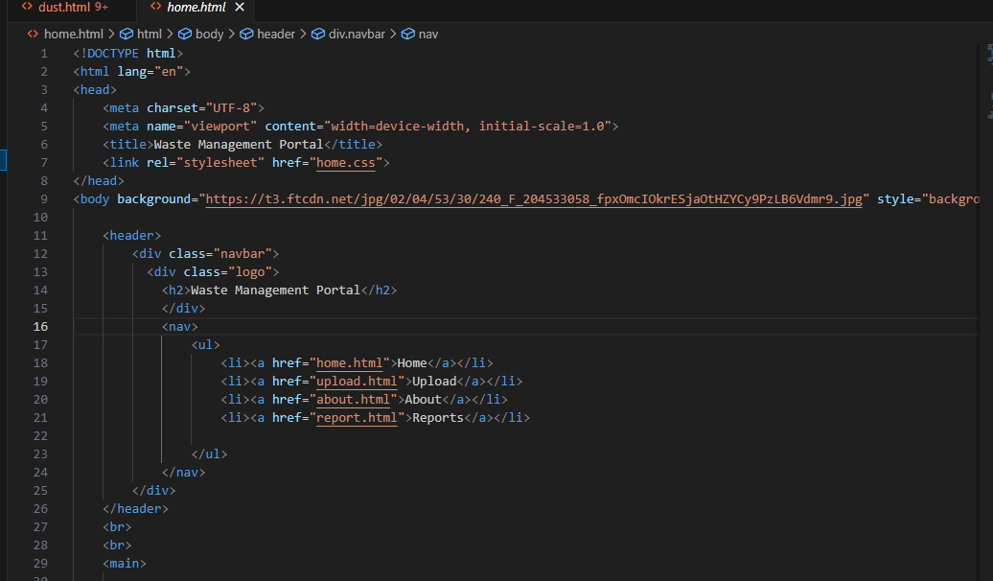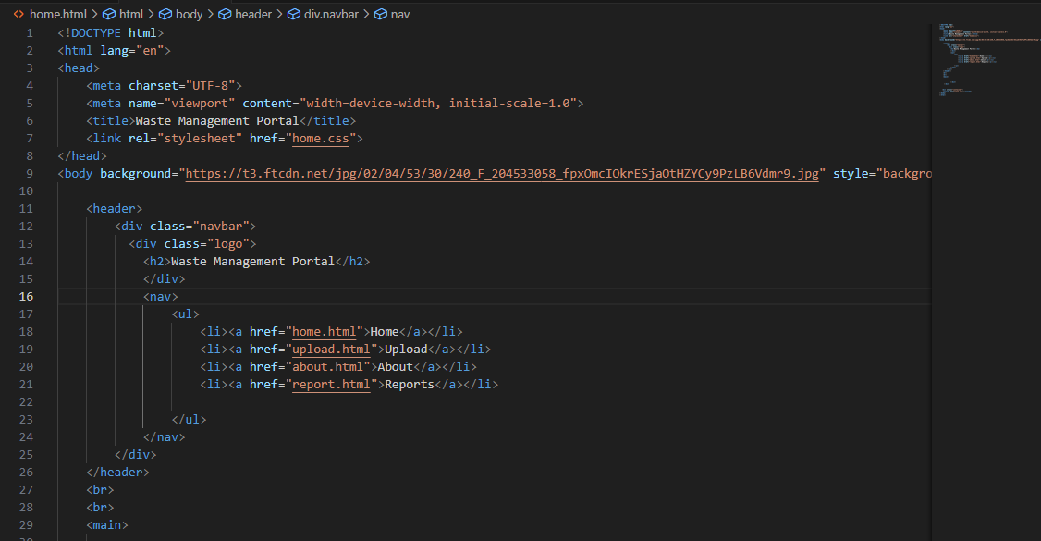

**CHAPTER-5**

**RESULTS**

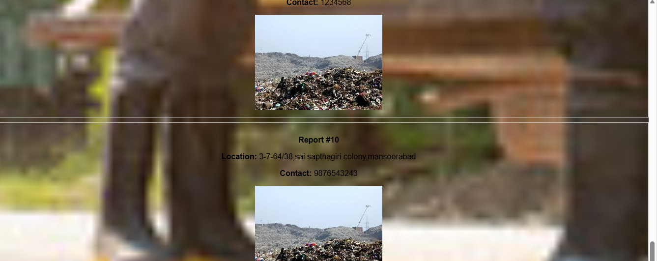

**CHAPTER-6**

**Advantages,Applications&Limitations**

6.1 Advantages

1. Reduces Environmental Pollution

2. Conserves Natural Resources

3. Promotes Public Health

4. Economic Benefits

5. Encourages Community Engagement

**6.2 Applications**

1**.** Municipal Waste Management Programs

2. Educational Institutions

3. Corporate Sustainability Strategies

4. Agricultural Use

5. Technology & Innovation

**6.3 Limitations**

#### **1.Lack of Public Awareness**.

#### 2. **Inadequate Infrastructure**

#### 3. **Improper Waste Segregation**

**CHAPTER 7**

**Conclusion&Future Scope**

**Conclusion**

Environmental sustainability through effective waste management is no longer optional—it is essential for safeguarding our planet. The successful execution of waste segregation, recycling, composting, and public awareness initiatives highlights the potential of collective action. By reducing pollution, conserving resources, and promoting a circular economy, waste management directly contributes to a healthier environment and community**.**

**Future Scope**

1. Advanced Waste-to-Energy Technologies

2. AI and IoT in Waste Management

3. Policy Development & Global Collaboration